|  |  |  |
| --- | --- | --- |
| **RPA on PDI**  Building your First Automation |  | A Series on |
| Hyperautomation |
|  | Lab 1 |
|  |

Objectives

In this lab you will gain an understanding of ServiceNow’s RPA offering and how to build RPA robots to automate any complex workflows. You will get familiarity with:

* RPA Hub and how to install it on a Personal Developer Instance
* RPA Desktop Design Studio to design automation.

1. Requires a PDI with Utah release.
2. Requires the RPA Hub Plugin App to be installed.
3. Requires a Windows machine.

Summary

As a developer, you want to explore ServiceNow’s capabilities of RPA Hub and the RPA Desktop Design Studio in a sub-prod environment. Starting with the Utah release, RPA Hub is available on PDI. By installing the relevant plugins, you will be able to kickstart the RPA journey using the ServiceNow platform!

Lab Exercise Summary

Part 1: Installing RPA Hub Plugin on a PDI

The following exercises will be covered in this Part.

* + Exercise 1.1: How to request a PDI.
  + Exercise 1.2: How to install the RPA-Hub plugin on the PDI.
  + Exercise 1.3: How to create robot license distribution record.

Part 2: Installing RPA Desktop Design Studio on a Windows Machine

We will cover the following:

* + Exercise 2.1: Locating the different RPA Plugins/ binaries on the PDI.
  + Exercise 2.2: Installing RPA Desktop Design Studio
  + Exercise 2.3: An overview of RPA Desktop Design Studio

Part 1: Installing RPA Hub Plugin on a PDI

* 1. How to request a PDI

Steps:

1. Login to developer.servicenow.com:



1. Click on Request Instance



1. RPA Hub on a PDI is only available on Utah and subsequent releases. Select Utah release and click on ‘Request’ button:

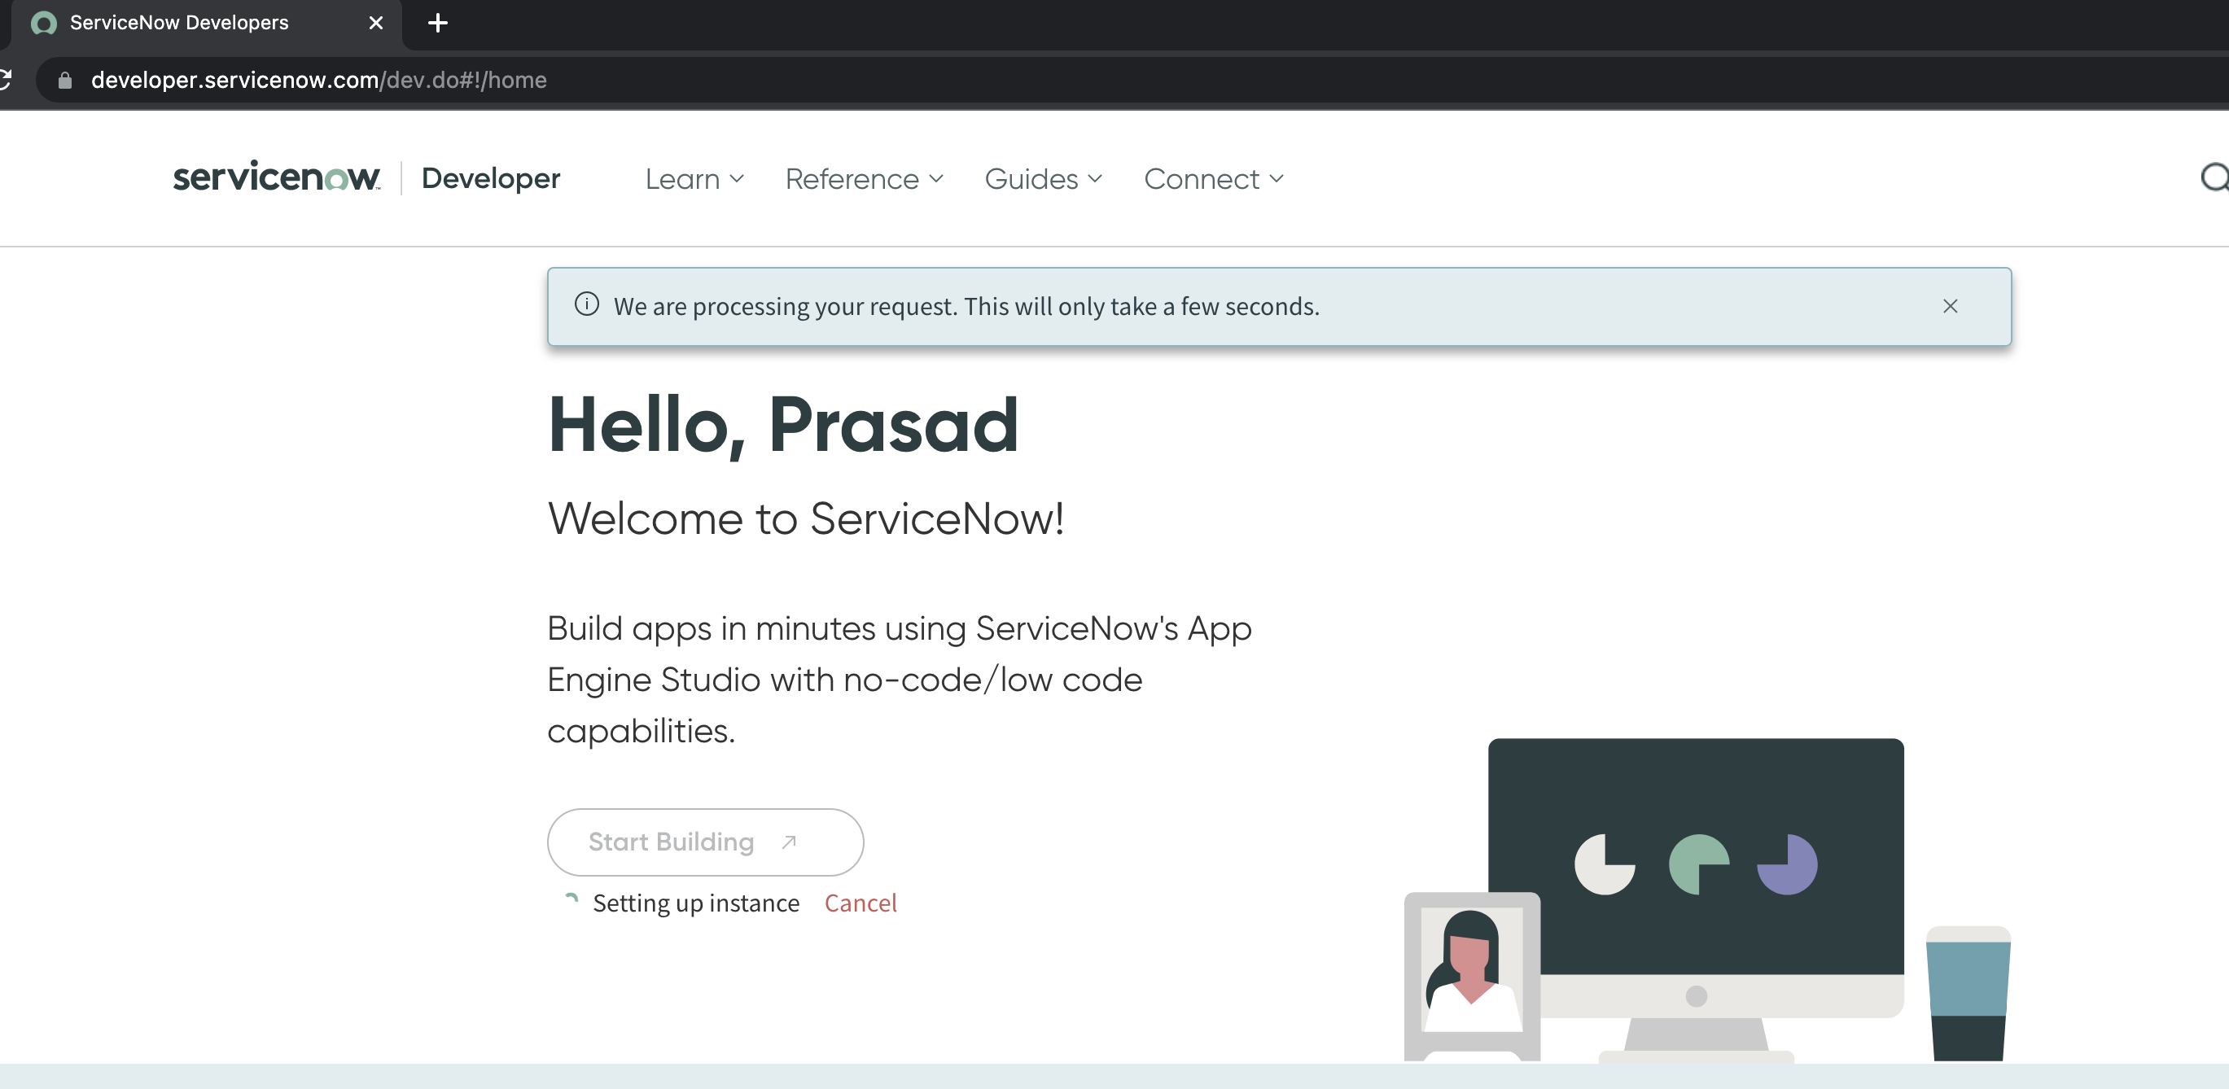

1. The instance creation request will be fulfilled in a few minutes:



1. Once the instance is ready, you will see a pop-up with the details. Note the instance URL and the login credentials.





1. For existing instances that are inactive, the developer can wake up the instance after logging in.





* 1. How to install the RPA-Hub plugin on the PDI

Once the PDI instance is available, login to the PDI using the credentials provided in previous step.

1. Click on ‘All’ and you will see a list of various applications on the instance:



1. Type ‘plugins’ in the search bar and locate the Plugins application. Click on it:



1. You will see a list of available plugins:

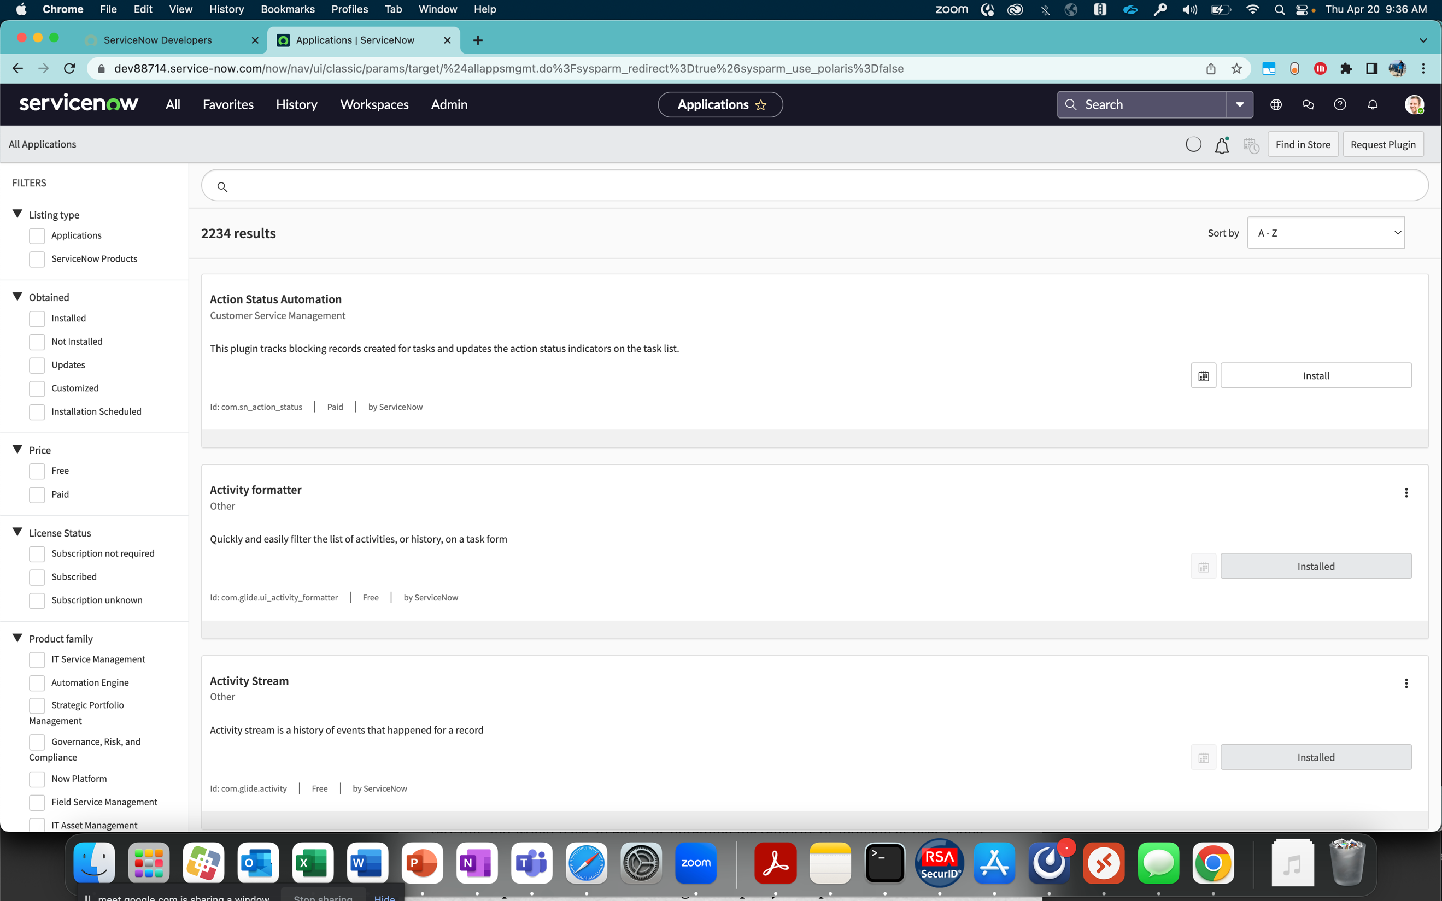

1. Search for ‘rpa’ plugins and you will see a filtered list. Click on ‘install’ button for the RPA Hub plugin:



1. Select the ‘load demo data’ checkbox and click on the Install button. This will also install the dependent applications such as RPA Plugin Bundle, as well as the CMDB CI Class Models plugin:



1. The installation process will begin and load the dependent applications.   
   Note: This process will take about 30 minutes.

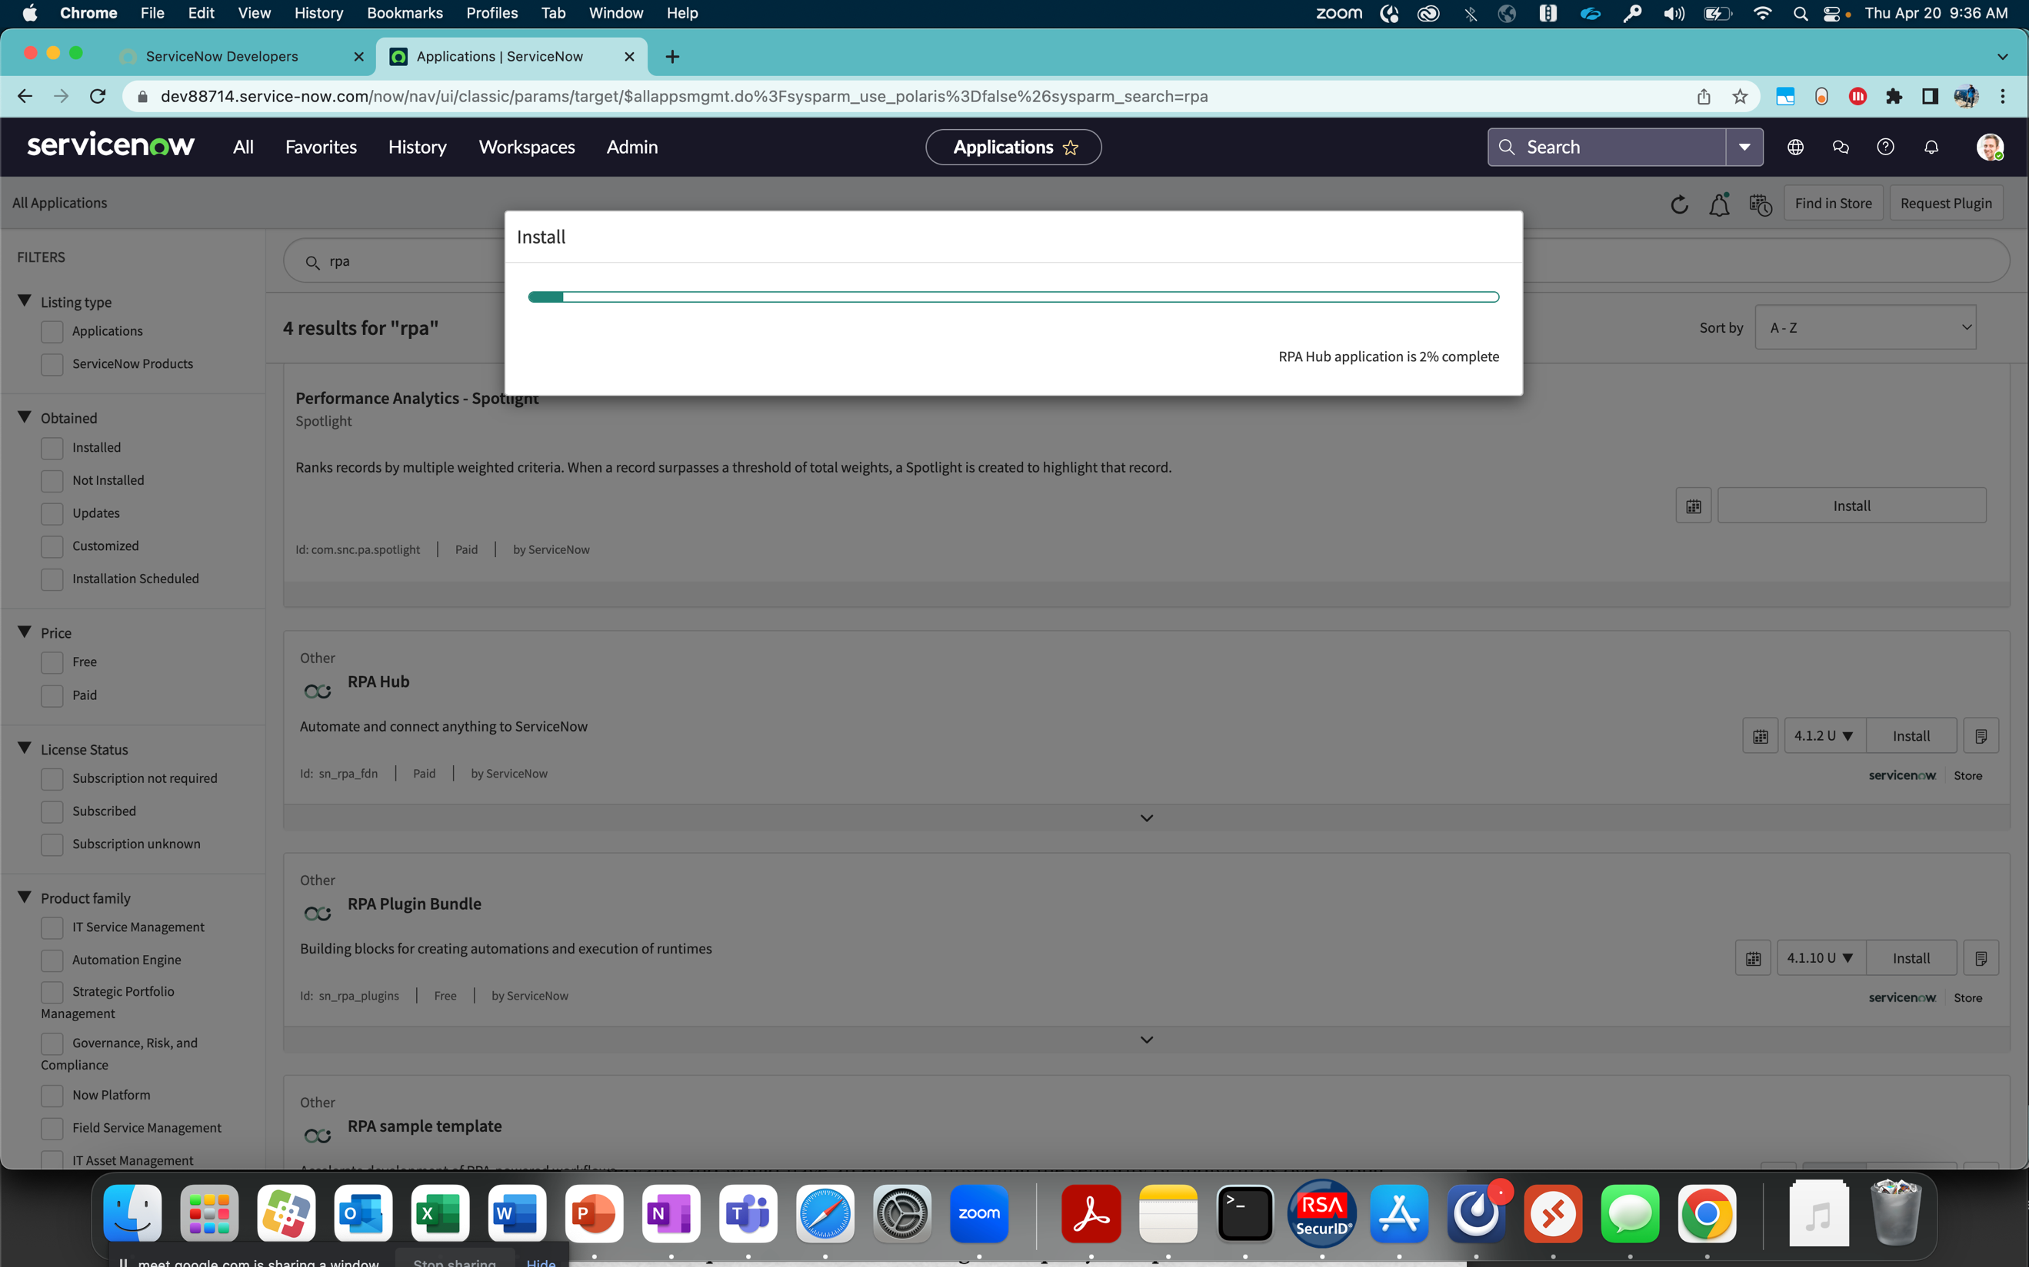

After the process is completed, if you refresh the page, the relevant plugins should be in ‘installed’ state:



1. Also, you will see the ‘Robotic Process Automation’ application in the list when you click on ‘All’. You may want to add ‘RPA Hub’ application to the Favorites list by clicking on the Star icon to the side of ‘RPA Hub’ link.

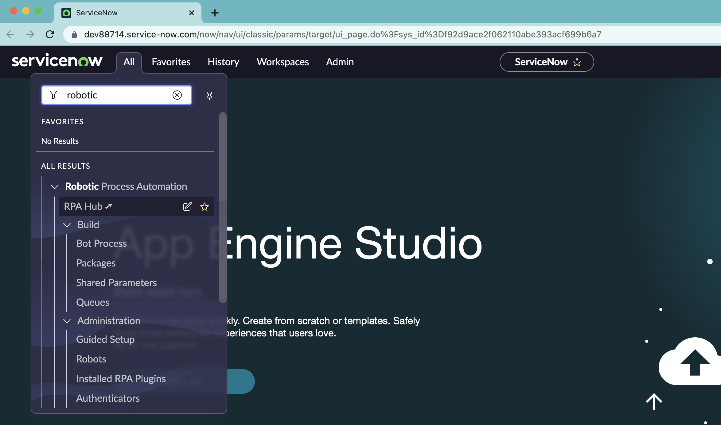

* 1. How to create robot license distribution record

An administrator can create a robot license distribution record to define the consumption and distribution of licenses in your organization. Only one record can be created per domain. For more information, refer to the [License distribution in RPA Hub.](https://docs.servicenow.com/bundle/tokyo-application-development/page/product/rpa-hub/concept/license-rpa-hub.html)

1. The next step is to enable the Robot licenses in the Robots License Distribution. For this, click on the ‘Robots License Distribution’ link.



1. Click on the ‘New’ Button



1. Developers using RPA Hub on a PDI are entitled with 1 unattended and 1 attended Robots. Click on Submit button.



1. The record is now updated, and RPA Hub is ready to use on a PDI! You may now proceed to next section.

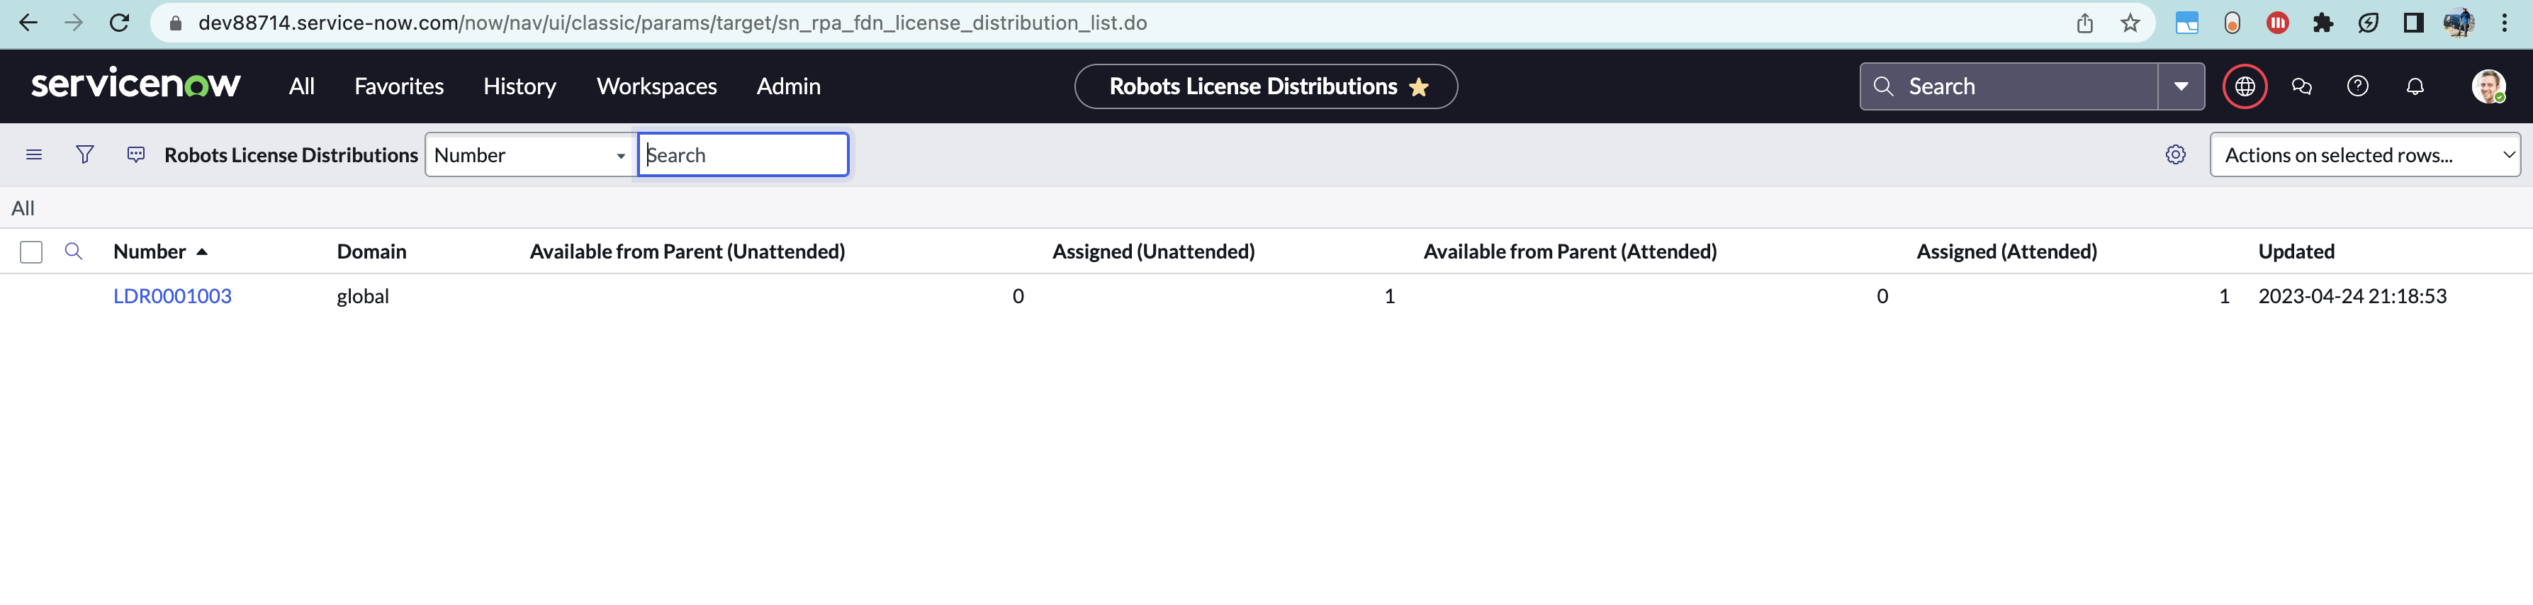

Congratulations on setting up RPA-Hub on your PDI!

Part 2: Installing RPA Desktop Design Studio on a Windows Machine

* 1. Locating the different plugins and binaries on RPA Hub in the PDI

1. Click on ‘Downloads’ under the Administration section of RPA Hub:



1. The RPA Downloads page shows the list of available binaries:



* 1. Installing the RPA Desktop Design Studio, Robots, and login agents

For this exercise, you need a windows desktop machine, windows server, or a windows VM. If you have a Macbook, you need to install a Windows emulator. Refer to [Installing Windows 10 on a Mac using VirtualBox.](https://www.howtogeek.com/657464/how-to-install-a-windows-10-virtualbox-vm-on-macos/)

1. Download the binaries on your Windows desktop machine:

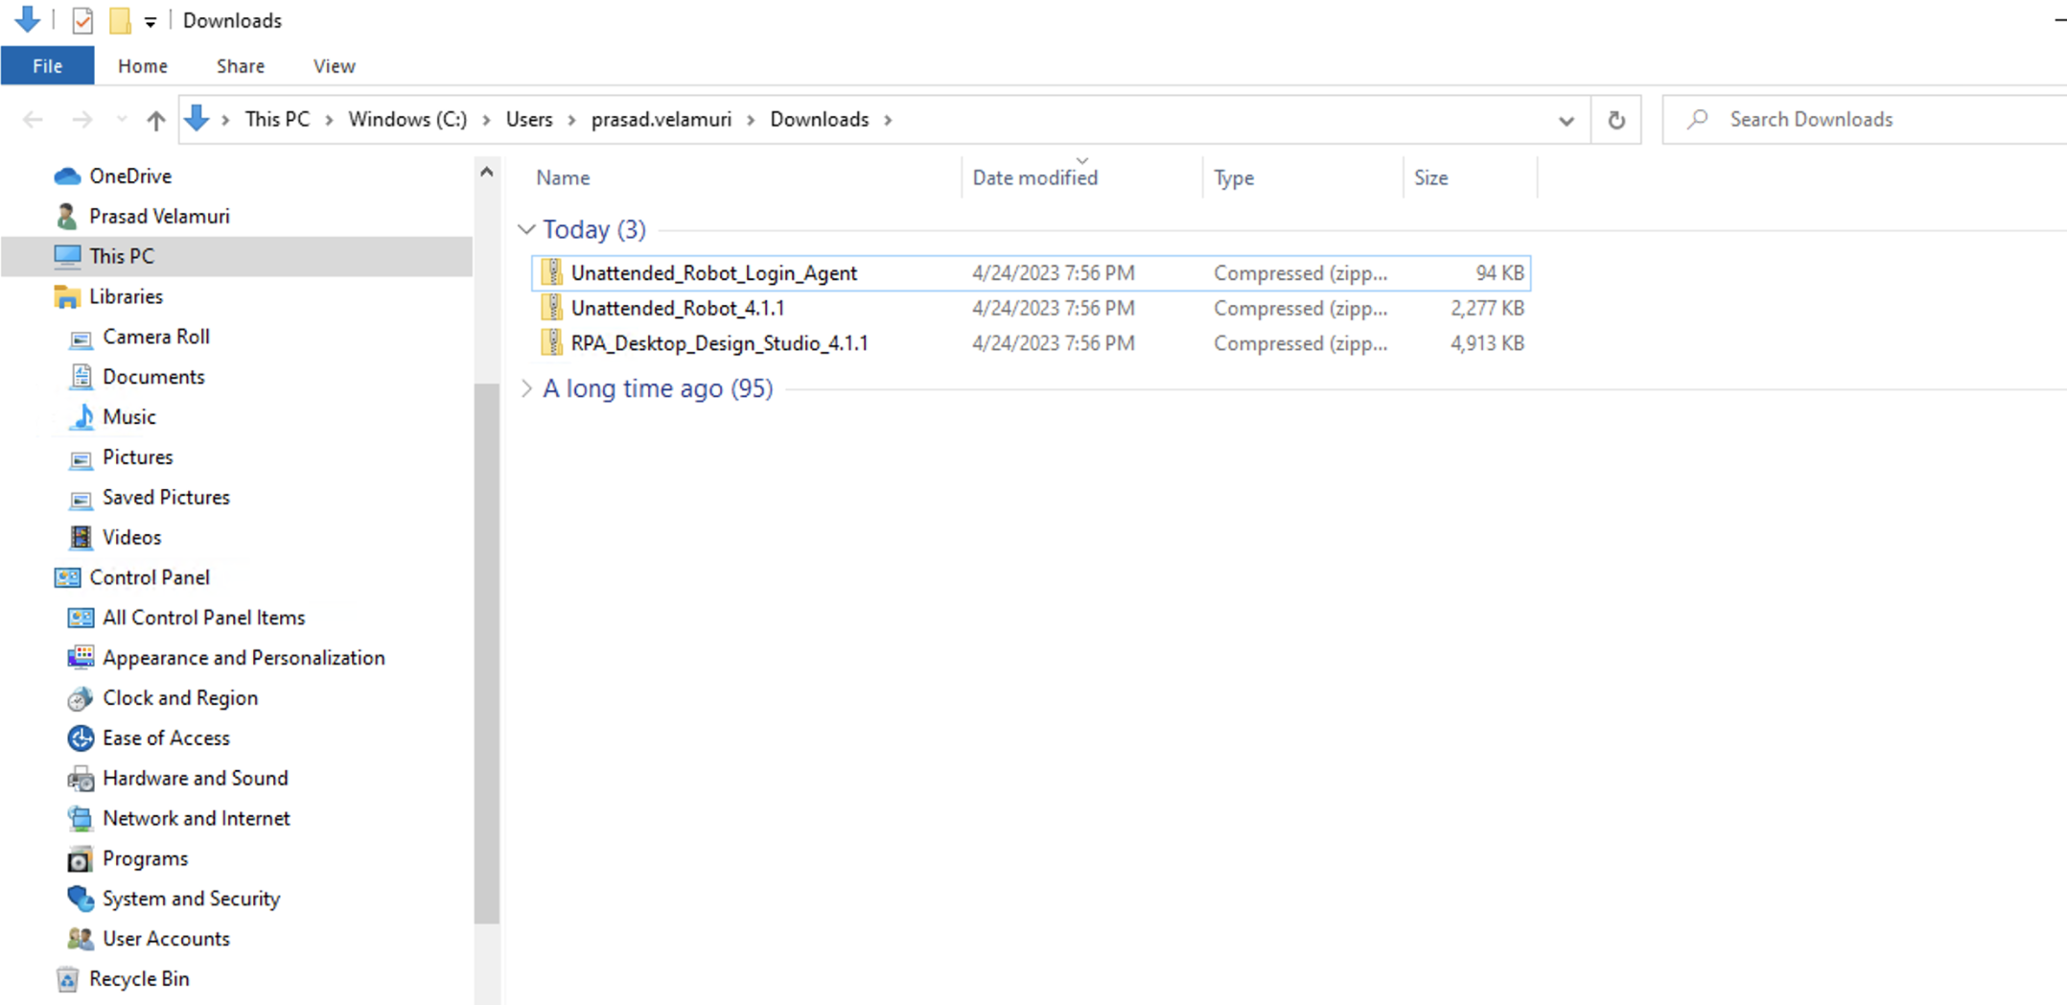

1. Extract the compressed files into separate folders:

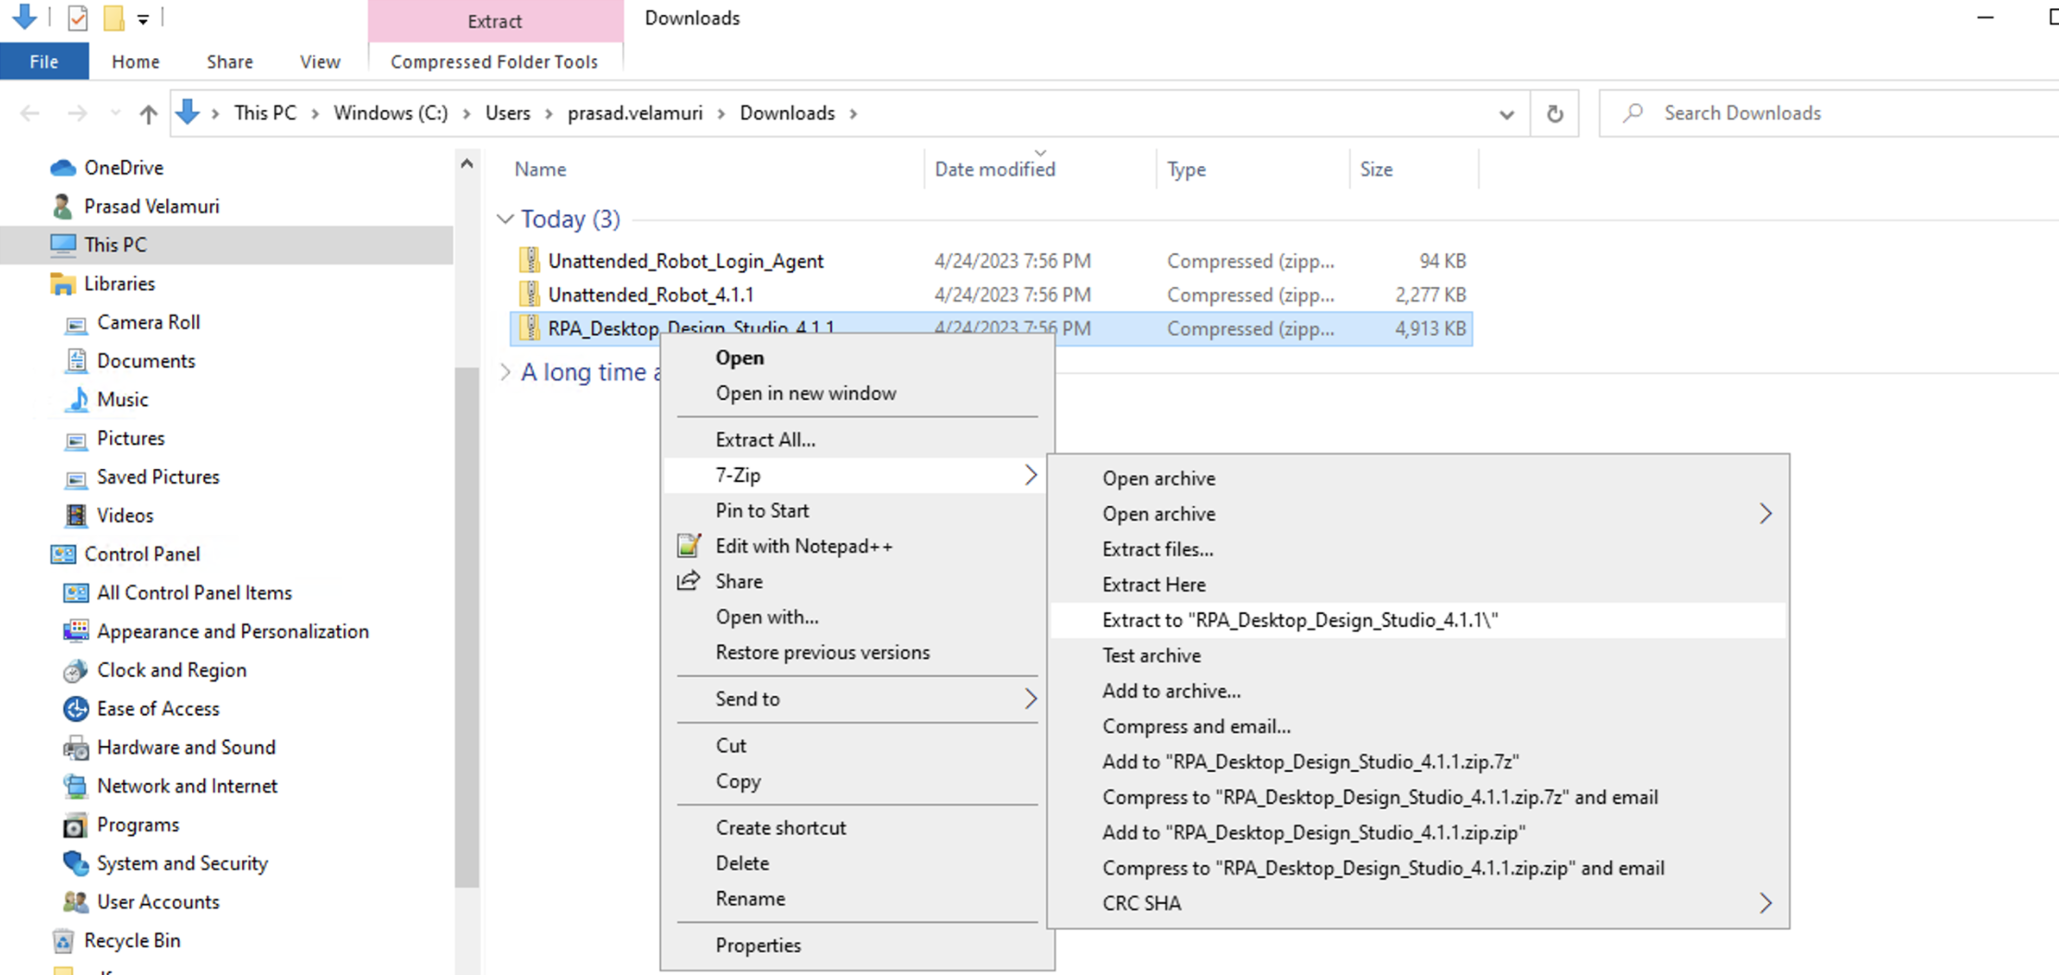

All the files are uncompressed as follows:

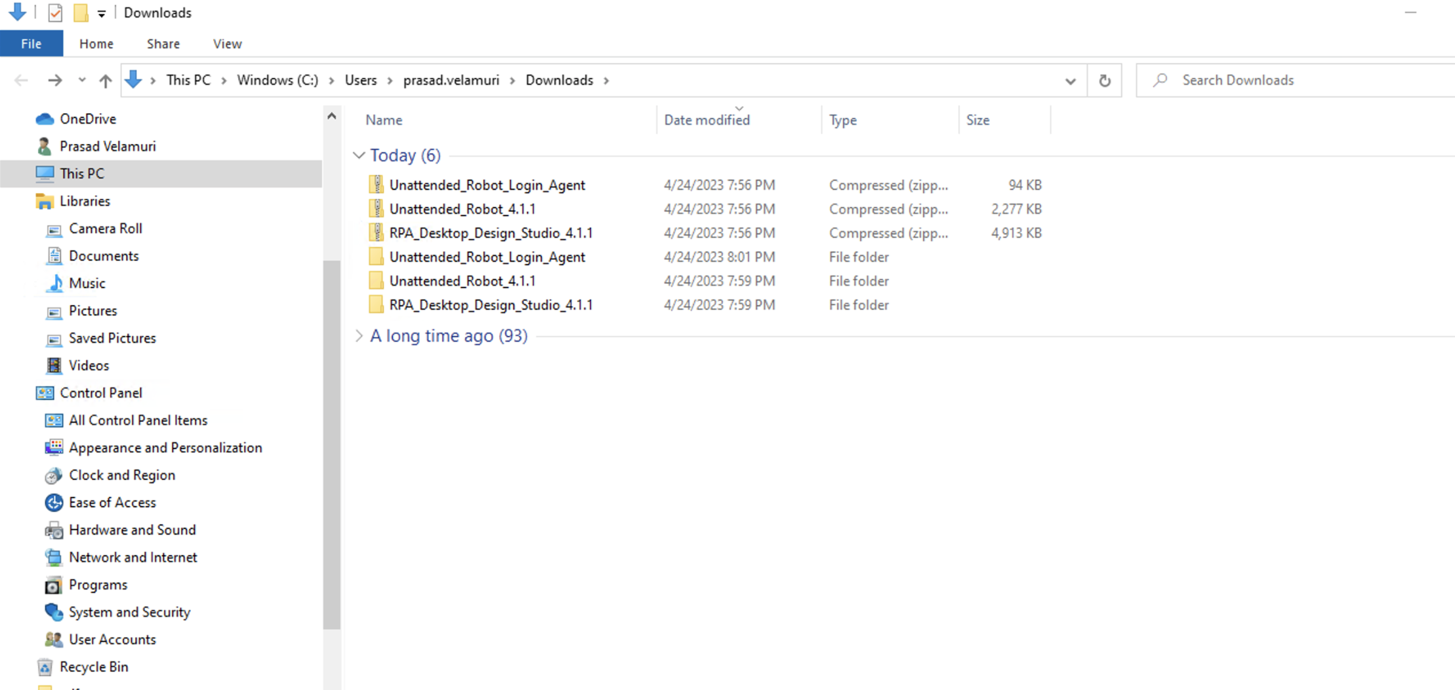

1. Install the RPA Desktop Design Studio, by right clicking on the executable and selecting ‘Install’ button:

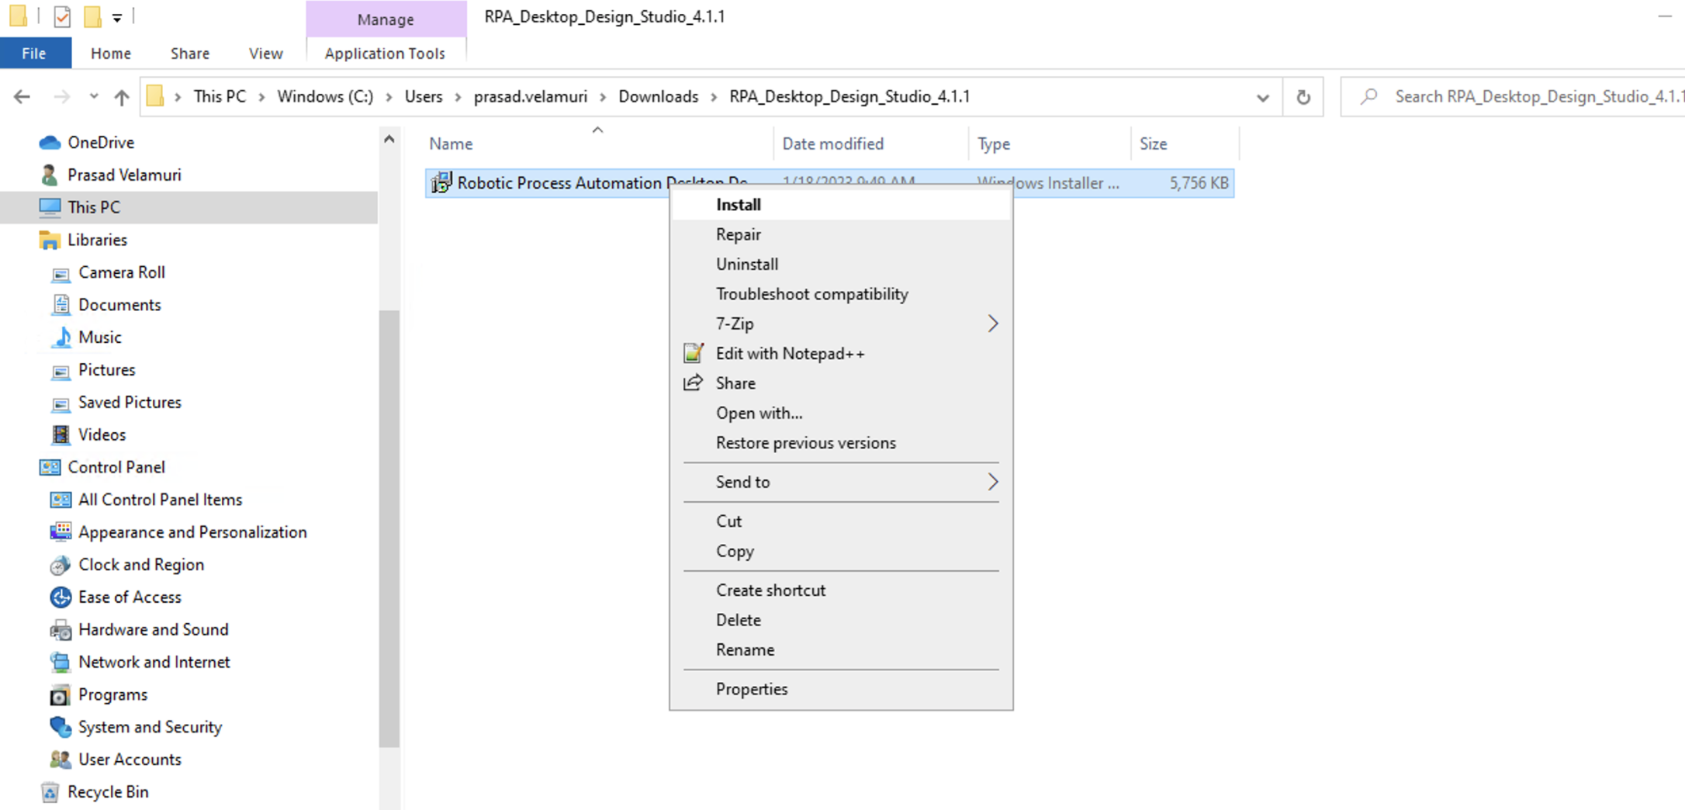

1. You will be provided with an installation wizard:

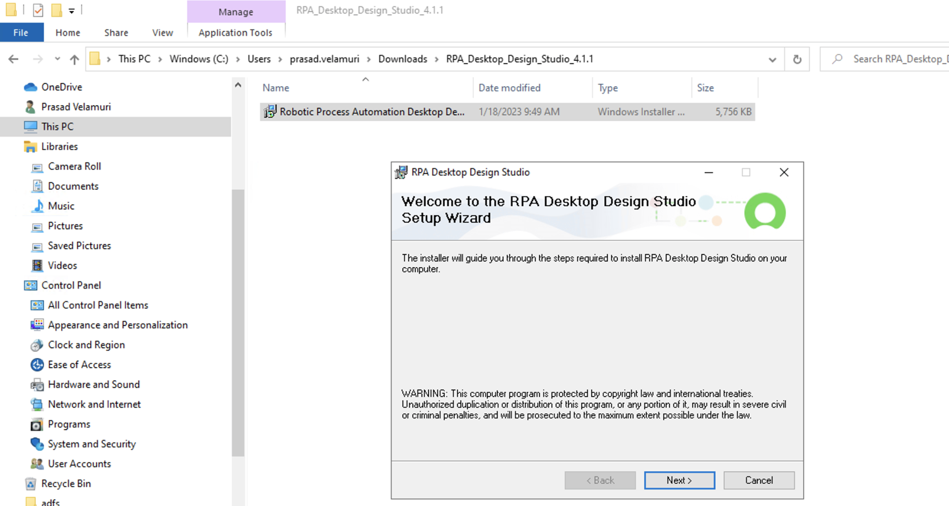

1. Select the relevant folder and click ‘Next’:

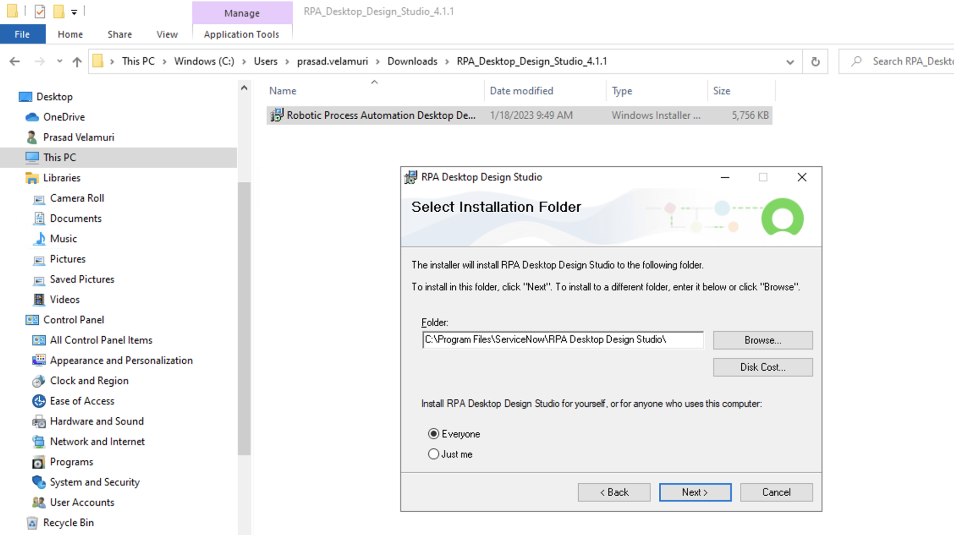

1. Confirm the installation by clicking ‘Next’:

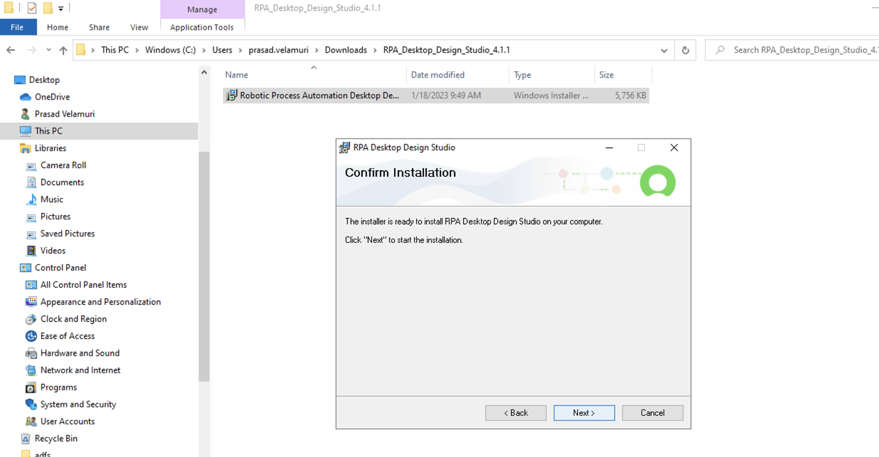

1. The installation should finish in a couple of minutes. Click the ‘Close’ button.

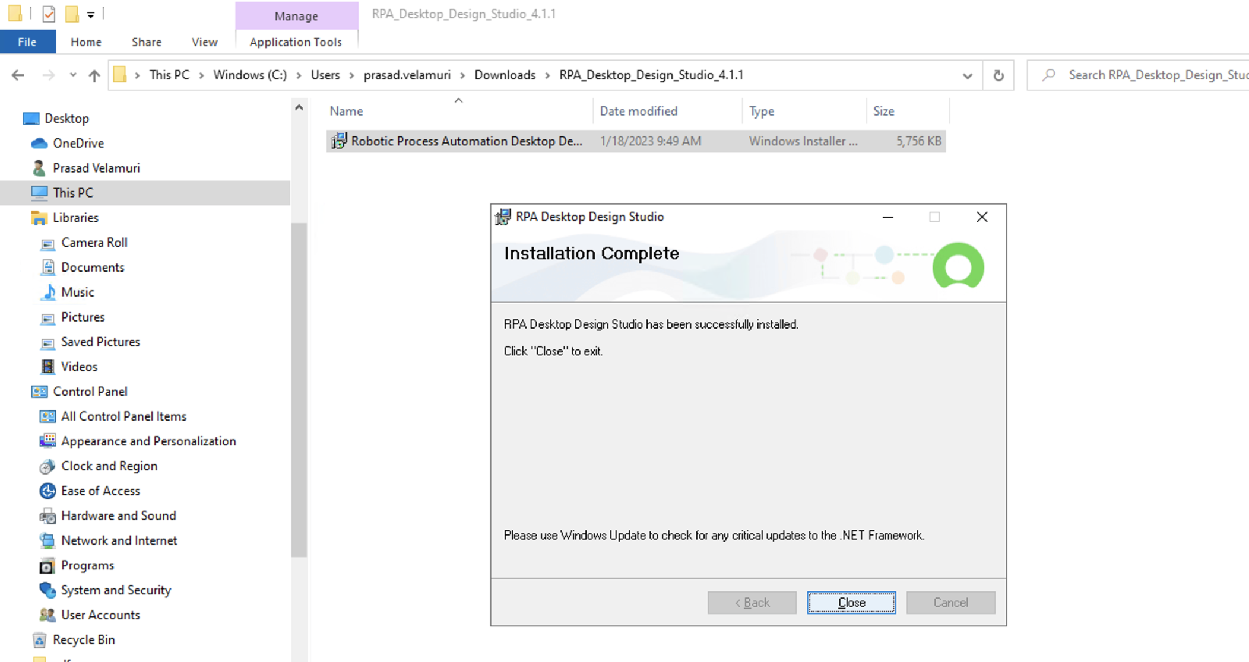

1. Install the login agent in the same manner:

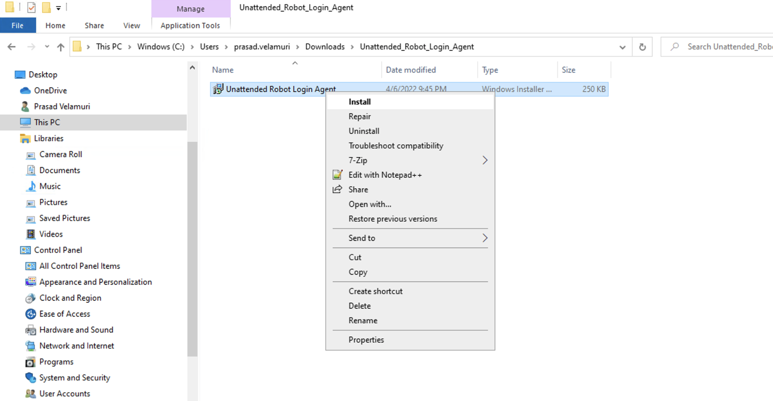

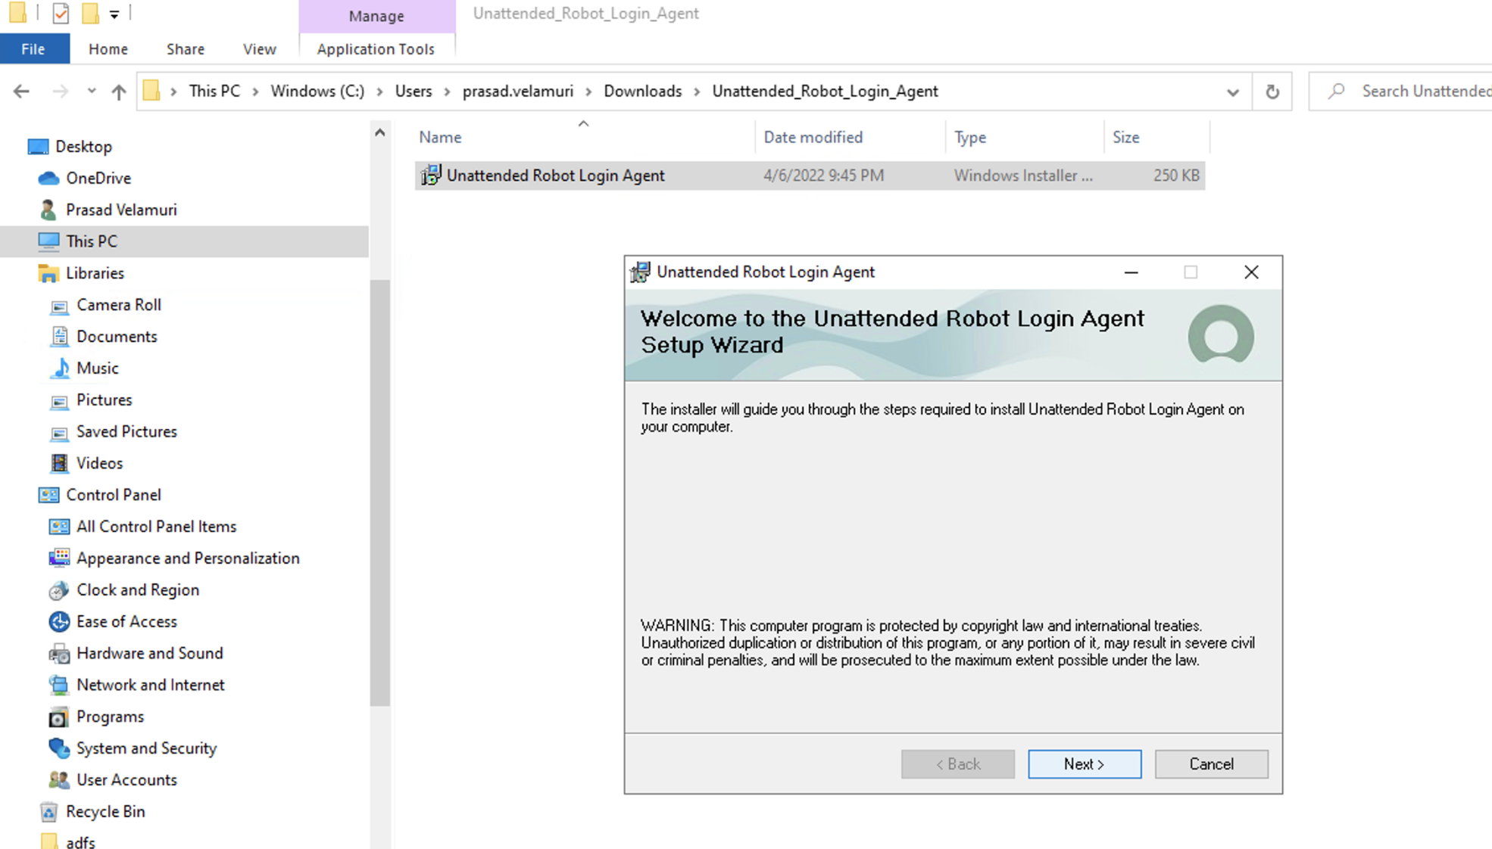

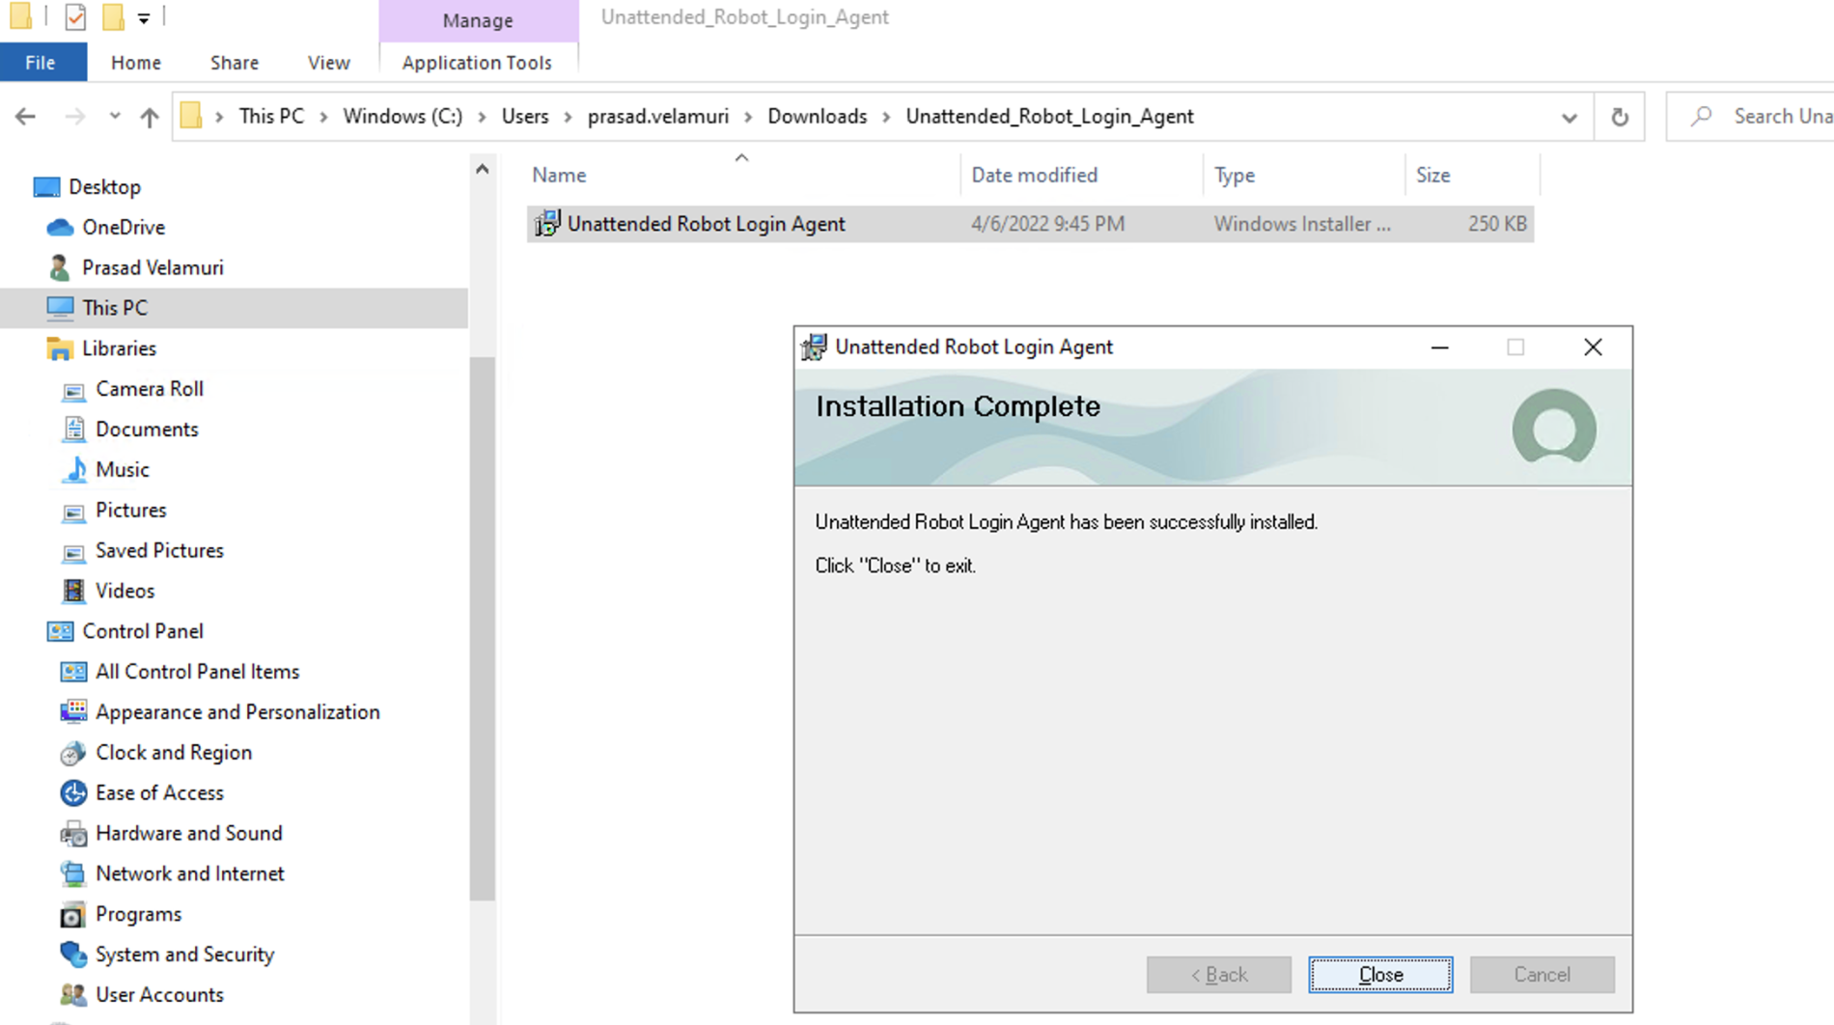

1. Install Unattended Robot in the same manner:

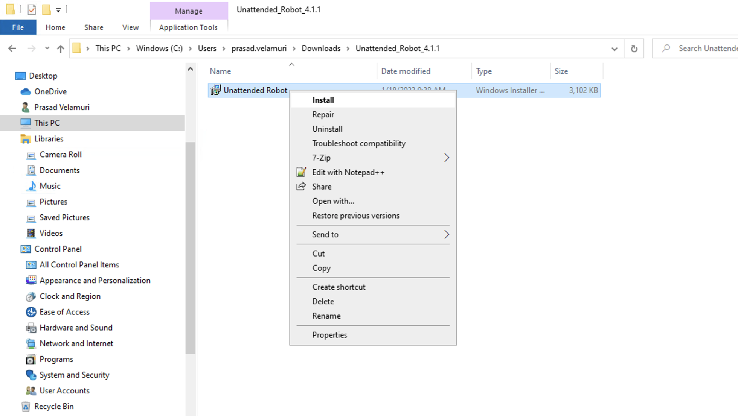

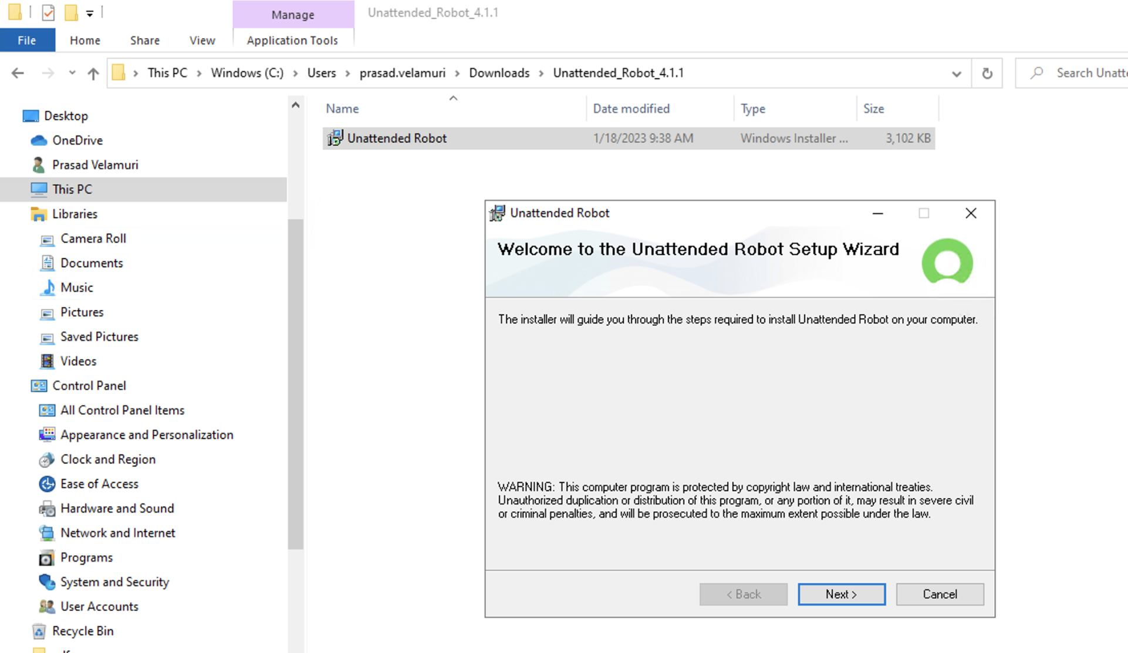

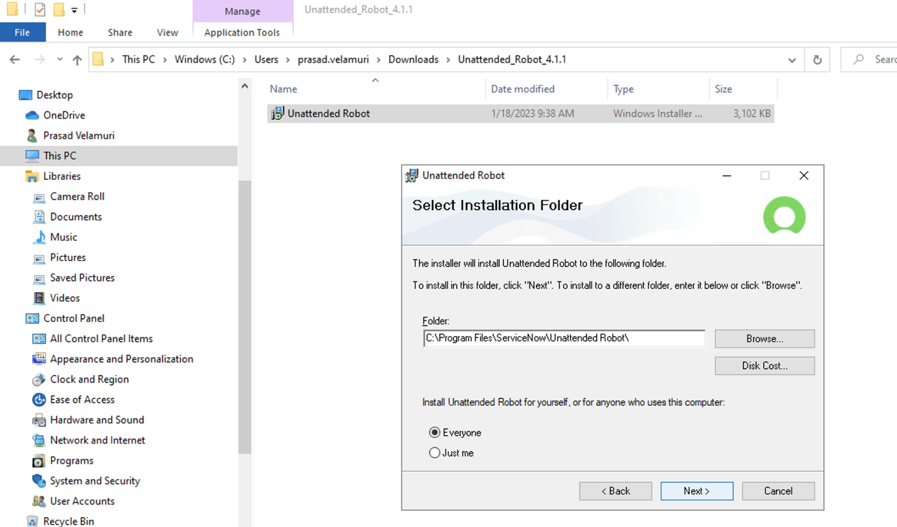

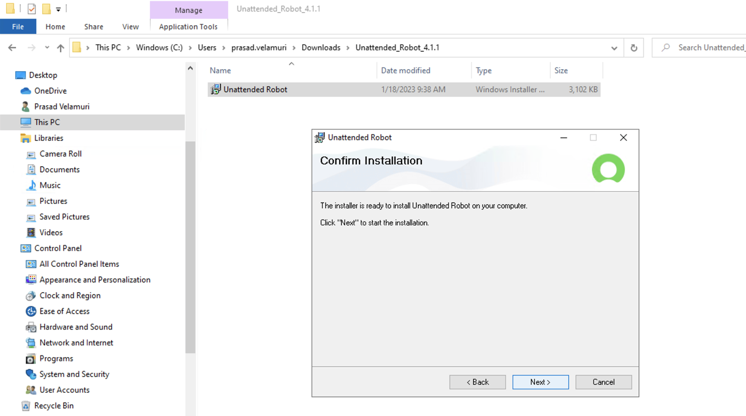

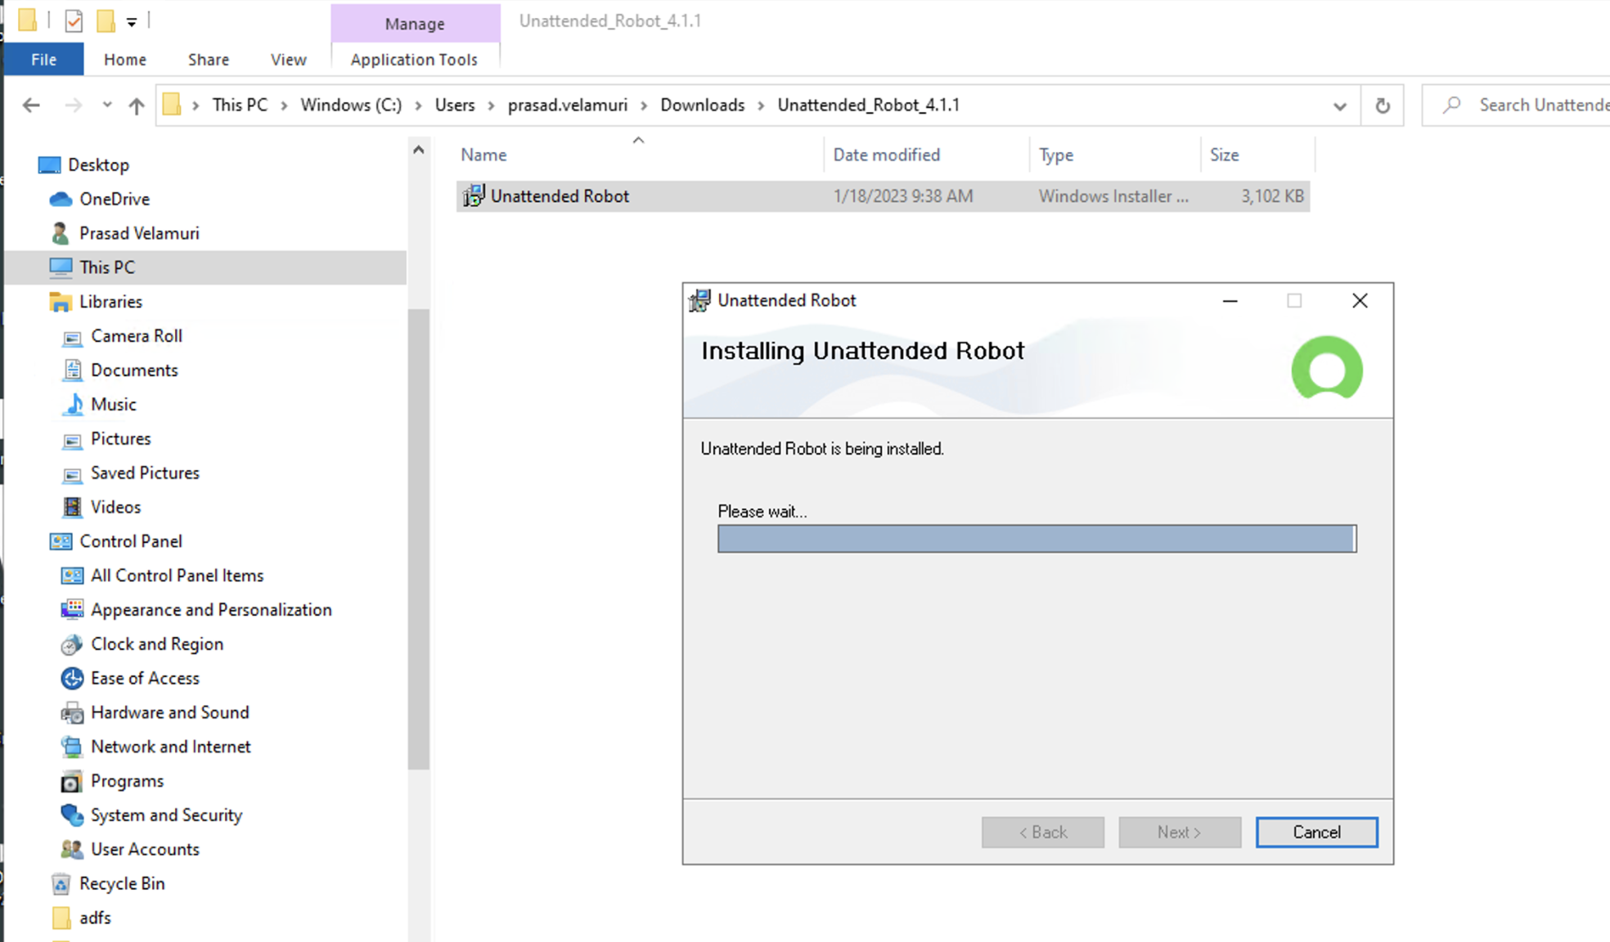

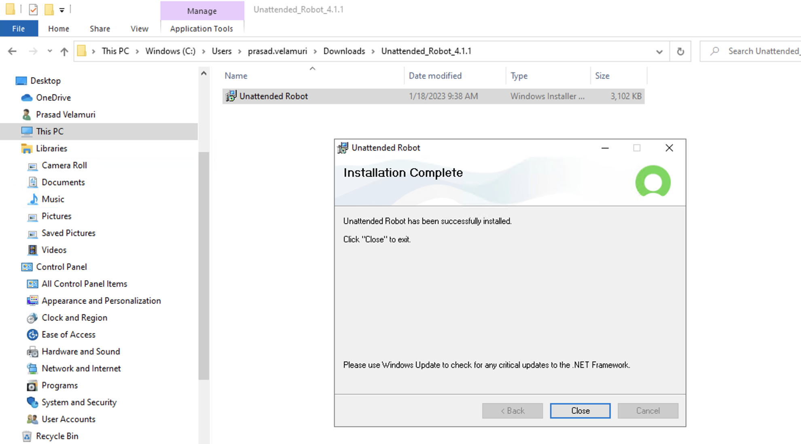

1. You may install the attended robot in a similar manner.
2. Locate the shortcut to ‘RPA Desktop Design Studio’ on the desktop and double click on it to open the application:

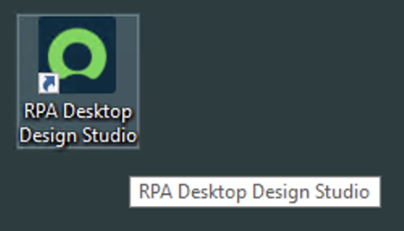

1. You will see the Connection Manager. It allows you to have connect the Desktop Design Studio to one or more instances containing RPA-Hub. Click on ‘Add New’



1. Provide the name and URL for the instance and click on ‘Proceed’ button:

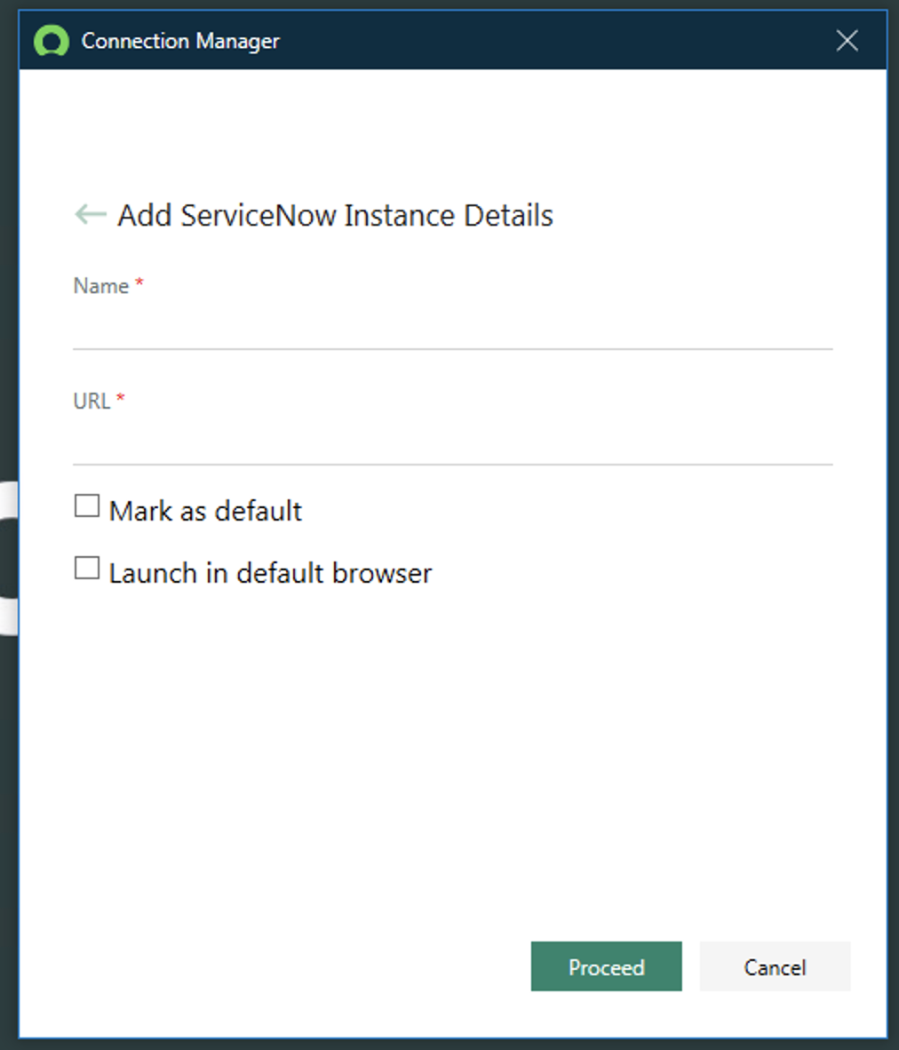



1. The application will load the relevant plugins and components:

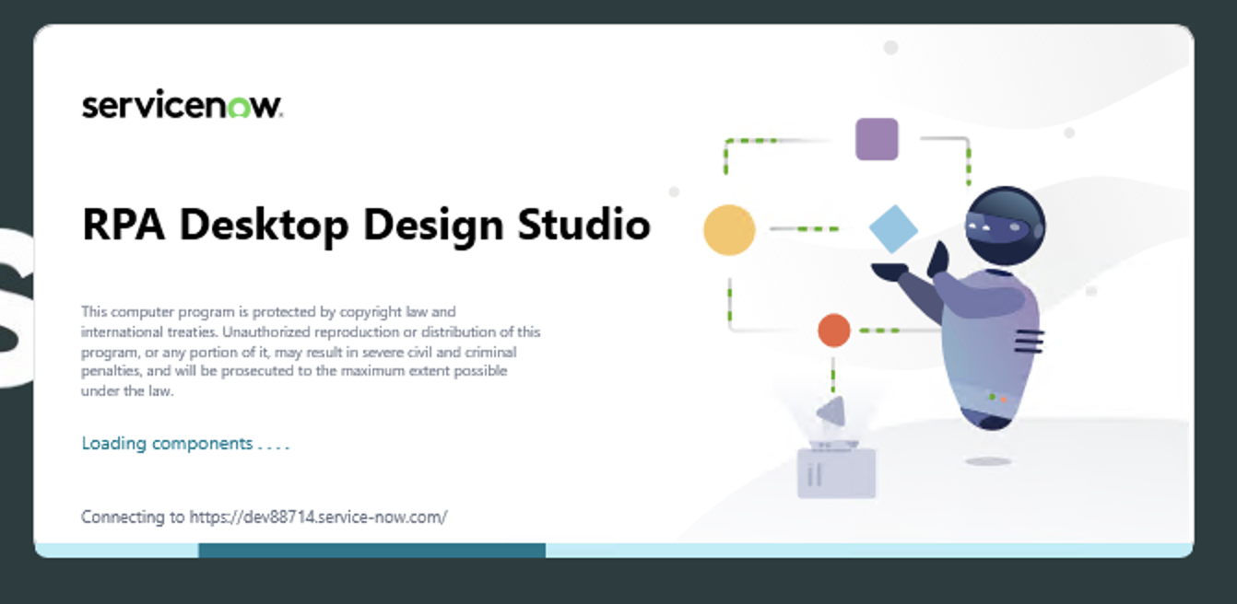

1. The RPA Desktop Design Studio is now ready to use!

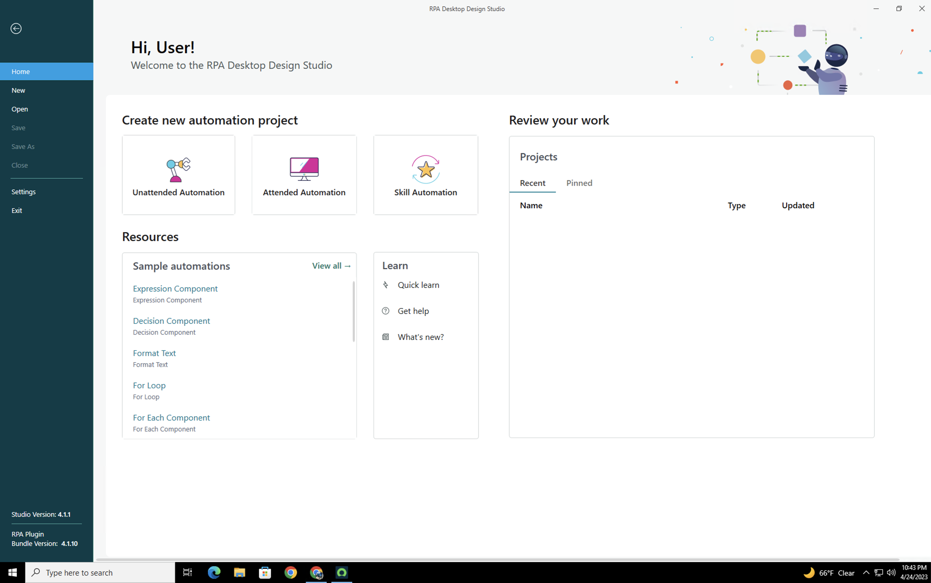

* 1. An overview of RPA Desktop Design Studio

RPA Desktop Design Studio features that enable you to design and create your business process automations.

Here are the key features:

* Provides a wide assortment of pre-designed components that you can use to create and design automations.
* Provides ease-of-use, scalability, and efficiency.
* Enables you to design automations in a code-free environment.
* Provides explanations about the errors and displays in simple-to-understand notifications.

Check this documentation link for an overview of the Design Studio:

<https://docs.servicenow.com/bundle/tokyo-application-development/page/product/rpa-studio/concept/rpa-studio-ui.html>

In the next lab, we will build an RPA bot using the RPA Desktop Design Studio.

Congratulations on Installing the RPA Desktop Design Studio on your Windows machine!